

|  |
| --- |
| **Computer Vision** |
| **Feature Extraction** |

Name: hanxue Liang

Student ID: 16-912-156

Catalog

1. Feature extraction 3

2. Feature descriptor 4

3. SSD Feature matching 4

4. SIFT features 5

5. Conclusion 6

In this exercise, I will computer feature detector and descriptor then find best matching features between two images. Then I will compare its results with the SIFT descriptor implementation by matlab.

## Feature extraction

Two images are provided as follows:



Figure1. Images for feature detection

I implement a Harris corner detector to find points of interest in an image. First step is compute the gradients Ix, Iy of the image in x and y-direction, then I compute the Harris response for every pixel.

Next I compute the Harris response measure for every pixel:

The points whose response is over a threshold are selected. Finally, I apply Non-Maximum-Suppression in a 3 pixel radius to these selected points and record the coordinates of these left points. The results for deferent threshold are shown as follows:

Threshold=0.0005:

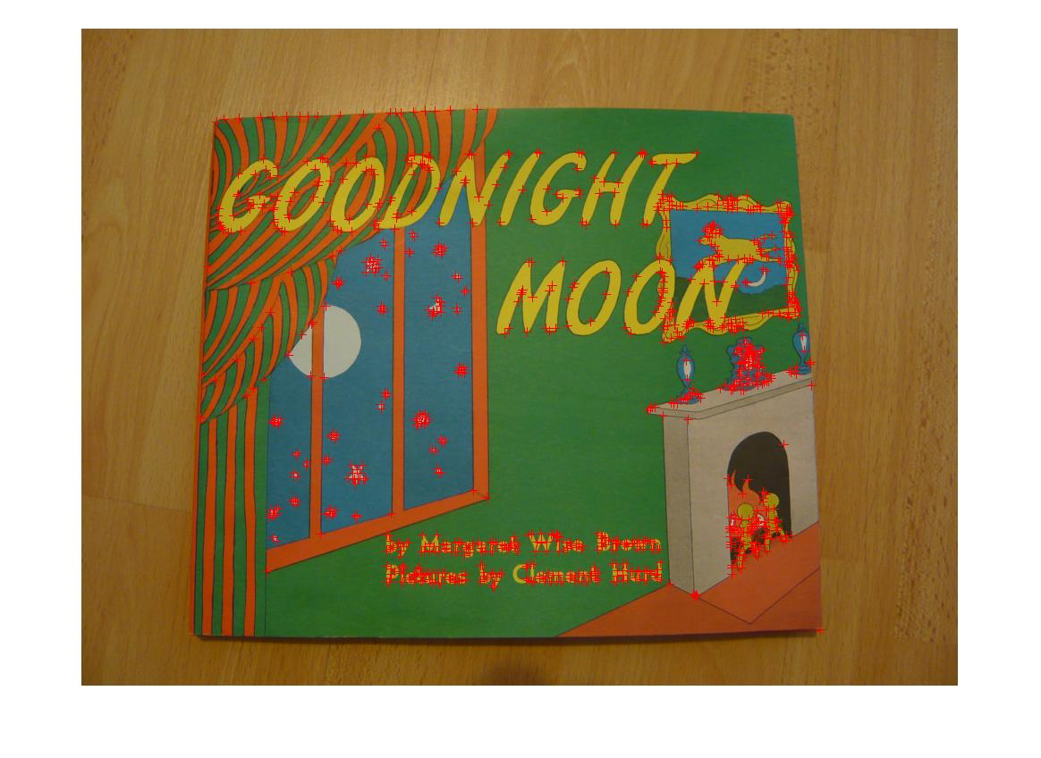 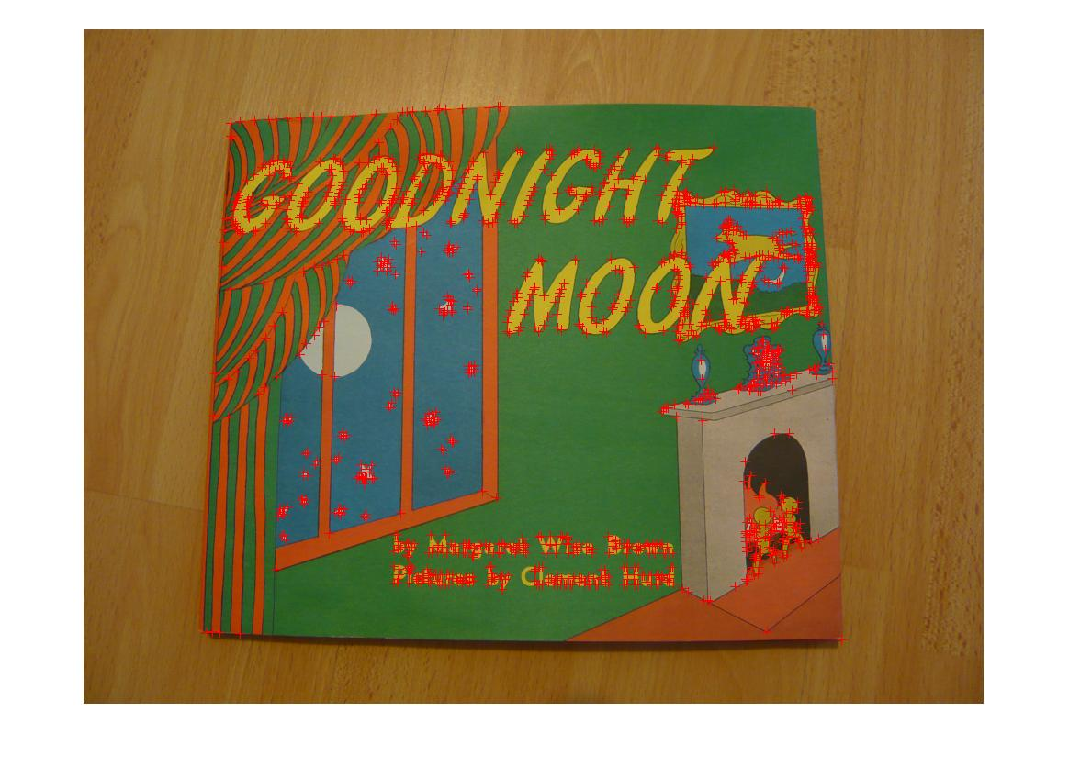

Figure2. Images with harris corner (threshold 0.0005)

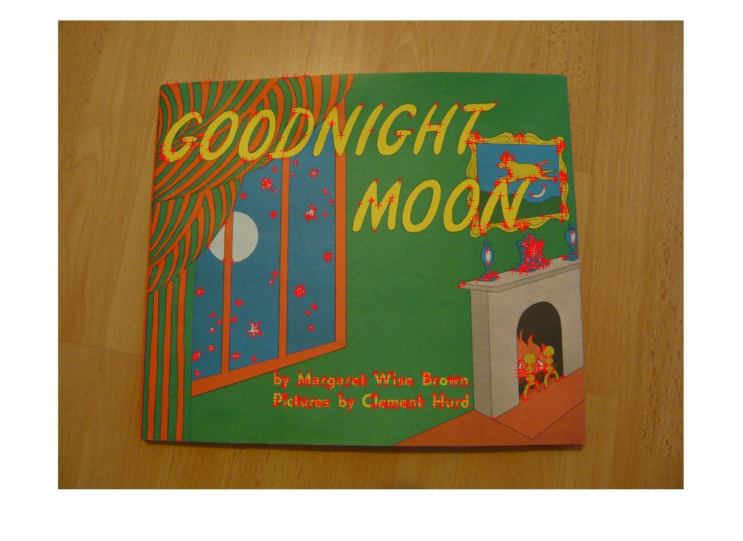 

Figure3. Images with harris corner (threshold 0.001)

It’s obvious and logic that images with threshold 0.001 have less harris corners than those of images with threshold 0.0005.

## Feature descriptor

Feature descriptor part I choose the simpler method, that is to computer a simple image patch of 9 × 9 pixels for one pixel.

## SSD Feature matching

I computer the sum of squared difference between two descriptors. Two descriptors with the lowest difference below a threshold will be considered as match. The results are as follows:

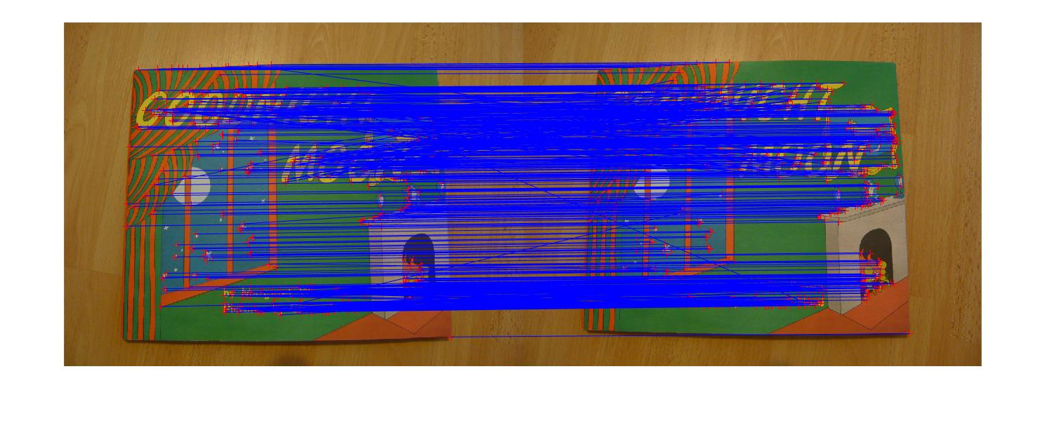

Figure5 match two images with threshold=0.11(harris response above 0.0005)

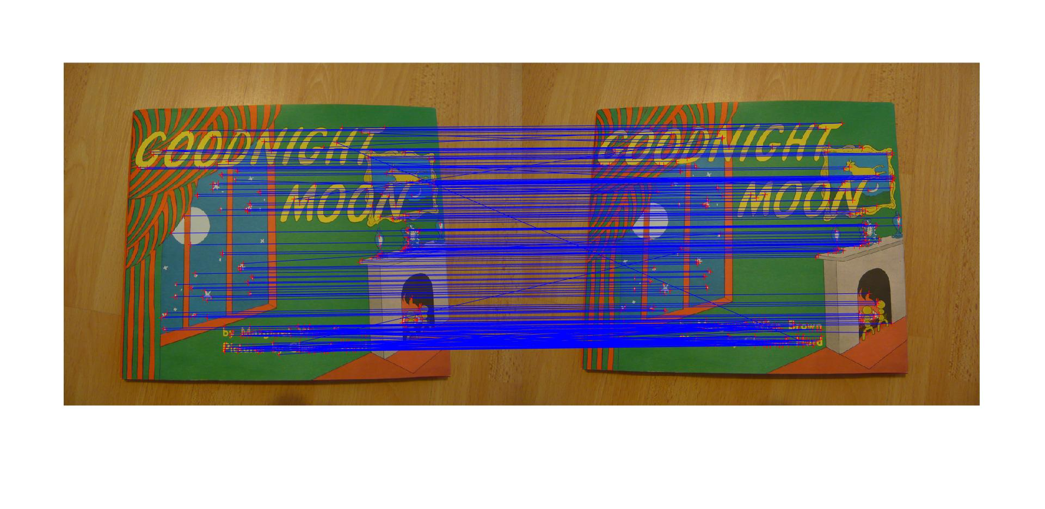

Figure5 match two images with threshold=0.11(harris response above 0.001)

## SIFT features

I use VLFeat open source library to realize the extract, visualize and match SIFT features. The implementations are done with different scales of the images and the results are as follows:

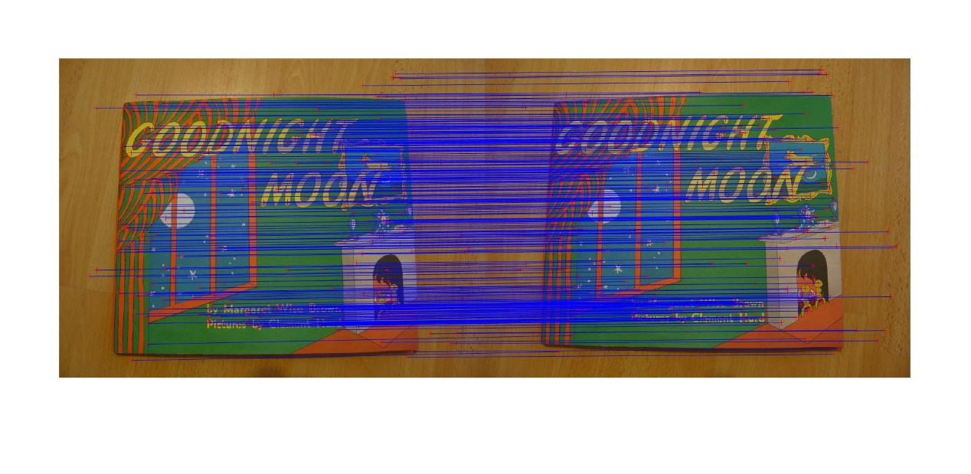

Figure6: Match two images (size 0.3) by vlfeat lib.

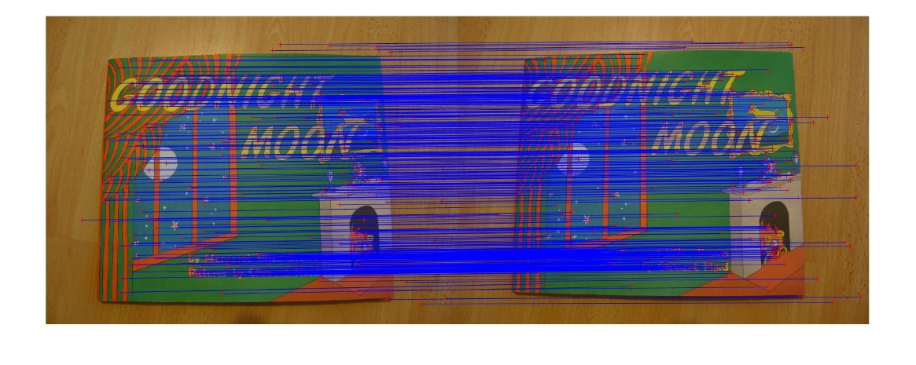

Figure7: Match two images (size 0.5) by vlfeat lib.

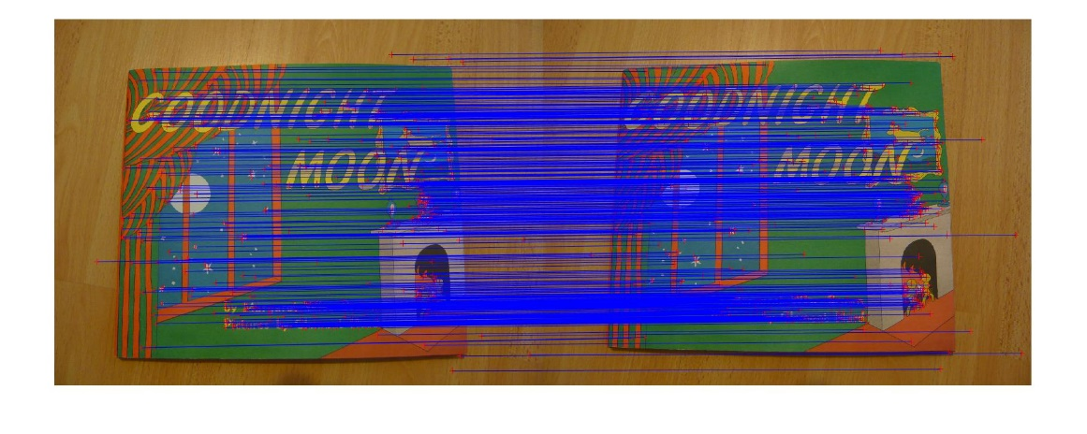

Figure8: Match two images (size 1) by vlfeat lib.

It is found that if we choose descriptors as patch of 9*9 radius, some matches are obviously not correct. So vlfeat has better performance than Harris corner detector. Even though both harris corner detector and Sift have rotation-invariant property, sift method actually has the advantage of scale-invariant. So changing the scale of the images would not affect the detection of the corner as which happens with Harris corner detector.

## Conclusion

By doing this exercise, I realize feature extraction by implementing harris corner detection, descriptor match as well as the vlfeat library. By comparison, I could find that SIFT algorithm is a more powerful than Harris corner detection.